Directions: Define the domain of the following functions.

$f(x)=\sqrt{x−4}$ D: _______________ $f(x)=x^{2}−\text{12}x+\text{32}$ D: _______________

$f(x)=\frac{x+8}{4x^{2}−\text{36}}$ D: _______________ $f(x)=\frac{5x}{2x^{3}−4x^{2}}$ D: _______________

$f(x)=\sqrt{\text{64}−x^{2}}$ D: _______________

Directions: Use interval notation to define the domain and range of the following graphs.
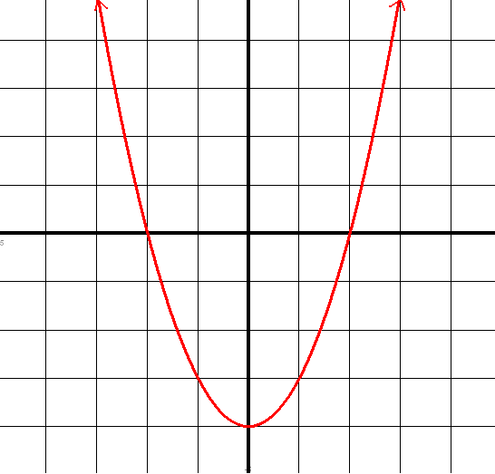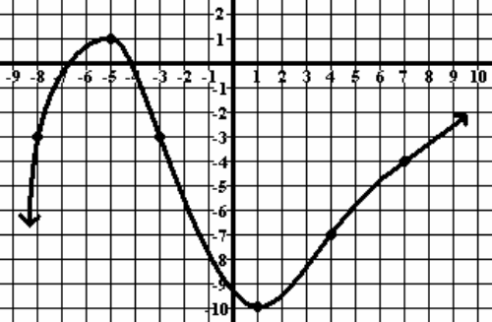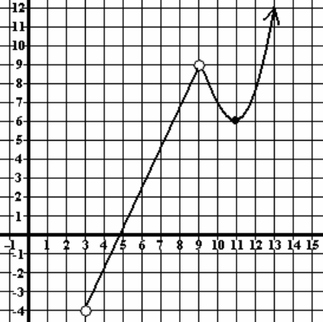

D: _______________________ D: _______________________ D: _______________________

R: _______________________ R: _______________________ R: _______________________

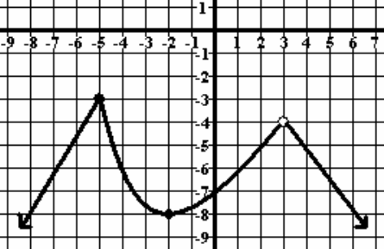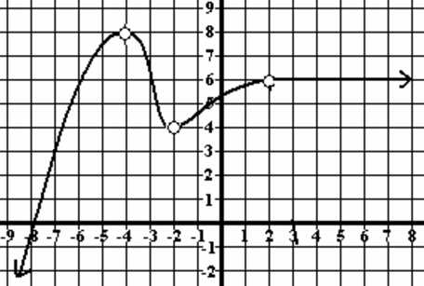

D: ____________________________ D: ____________________________

R: ____________________________ R: ____________________________

